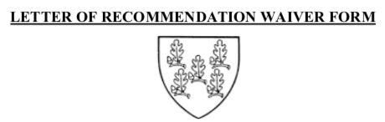
ADAMS HOUSE
26 PLYMPTON STREET
CAMBRIDGE, MASSACHUSETTS 02138-5004
PHONE (617) 495-2260 FAX (617) 495-0331
Please email your letter and completed waiver to Adams_Coordinator@fas.harvard.edu
STUDENTS: Complete Sections A and B and give this form signed to your recommender in person or electronically.

RECOMMENDERS: Complete and sign Section C. (at bottom of page) then attach this form to your recommendation and preferentially send both electronically to Adams_Coordinator@fas.harvard.edu. Alternatively, you can send in the pre-addressed, pre-stamped envelope provided by this student. If the student has waived the right to see your recommendation in Section B. below, please type "CONFIDENTIAL" at the top of your letter.
Please address your letter “To the Members of the Admissions Committee:” and compose it on official letter head.
NAME OF STUDENT (please print) _________________________________________CLASS YEAR: _______
NAME OF RECOMMENDER (please print) ____________________________________
PURPOSE OF RECOMMENDATION: ________________________________________
DATE RECOMMENDATION DUE AT ADAMS HOUSE: _______________________
Section A. Consent:
In conjunction with the Family Rights and Privacy Act of 1974, I, the above-named student, do hereby give Harvard University and Adams House permission to release this letter of recommendation to any person or place designated by me, or for use in forming composite letters, such as Dean's Letters. This consent is to remain in effect until revoked by me in writing.
Section B. Waiver: I, the above-named student, waive____ // do not waive ____ (indicate your choice) any right of access I may have, as provided by law, to this letter of recommendation.
Section C: Recommender Authorization:
I do ____ // do not ____ (indicate your choice) authorize use of portions of my letter in any composite House recommendations which may be requested by this student. (Please note: if the student has waived the right to see this recommendation, please write "CONFIDENTIAL" at the top of your letter.)

