Introduction
I. Welcome!
II. Why do you want to be a physician or enter the pre-health track?
III. Goal-setting
- Risk/benefit ratio in decision-making
- Determine your goals both inside and outside of medicine

Resources
I. Resident Tutors:
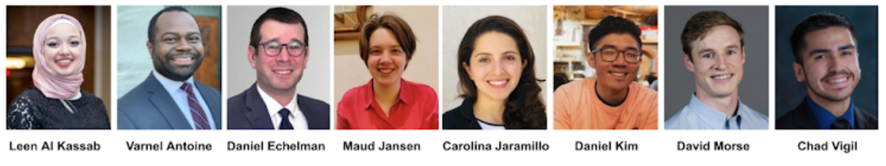
- Varnel Antoine (Co-Chair), Dan Kim (Co-Chair), Leen Al Kassab, Carolina Jaramillo, Maud Jansen, David Morse, Daniel Echelman, Chad Vigil
- E-mail: adams-medical@lists.fas.harvard.edu
- Website: https://adamshouse.harvard.edu/pre-med-advising

II. Non-resident tutor (NRT) staff
- Role of the NRT
- Medicine as a career choice (especially useful for the undecided)
- Non-medicine NRTs are also available - please let the tutor team know if you are thinking of a different health professions graduate school
- Application process: writing Dean’s letter
***Bottom line: Get to know your NRT!!***
- We’ll be having study breaks to get to know them.
- Be proactive and contact them! They are key support system in preparation for and during the application process

III. Office of Career Services (OCS)
- Rob Harrington and Oona Ceder (premed@fas.harvard.edu)
  - They should be contacted as soon as possible if you are considering non-MD programs (e.g. vet school, dental school, PA school, nursing school)
- ***OCS Pre-Health website: https://careerservices.fas.harvard.edu/channels/pre-med-students/
  - Premedical Information for Harvard Students
  - Sign up to the pre-health listserv: OCS Medical School Applicant Listserv.
- Medical school information – including alumni evaluations of schools (this is most appropriate when deciding on a school list for applications)

IV. Published books, other resources
  - Medical Schools Admissions Requirements (MSAR)
  - OCS Booklet with Harvard Undergraduate-specific data (email premed@fas.harvard.edu for access)
  - AMCAS website --http://www.aamc.org/students/amcas/
  - Other – medical school websites

V. Financial resources
- Fee Assistance Program (up to two calendar years from when you submit your Fee Assistance Program application)
  - Reduced registration fee, from $330 to $135, for MCAT exams until December 31st of the year you submit your Fee Assistance Program application
  - Complimentary access to the Medical School Admission Requirements (MSAR) website ($36 value)
  - Waiver for all AMCAS fees for one (1) application submission with up to 20 medical school designations ($1030 value)
  - Waiver for AAMC PREviewTM professional readiness exam registration fees ($100 value).
  - Effective calendar year 2022, the AAMC has modified two of its eligibility requirements for the Fee Assistance Program:
    - Removed the U.S. citizenship and certain visa status eligibility requirements, and will instead require a U.S. address.
    - Removed the requirement for parental financial information for applicants age 26 and over on the day the application is submitted.
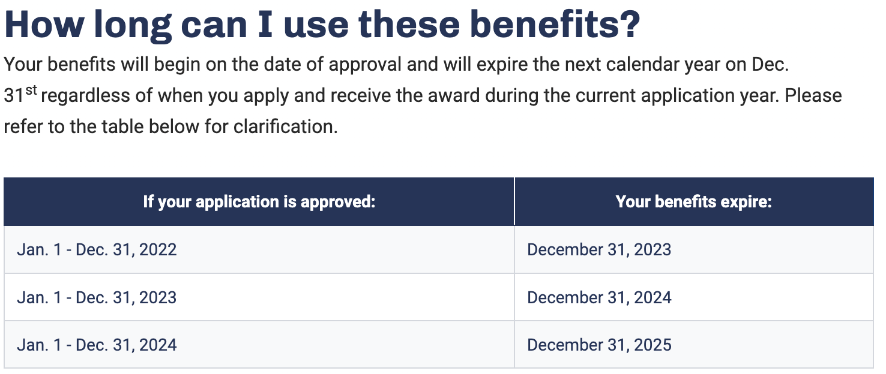
- Financial Aid Office
  - Reach out to your financial aid officer about your options to taking out additional loans to apply to graduate school (deferred while in graduate school and more)

Components of a successful medical school application
I. Numbers
- Grades—yes, they are important [OCS Med School Admission Data]
- Importance of science GPA
- Pre-med requirements – Biology (with lab), Chemistry (with lab),
- Physics (with lab), Math/Statistics, English: please see OCS website for list

II. MCAT
- About the MCAT:
  - What is it: Electronic, but not adaptive
  - When is it: Now offered very frequently, but dates fill up fast
  - How long does it last: Expires in ~ 3 years
  - How to afford: Please apply to the Fee Assistance Program before booking your MCAT to save on money with reduced MCAT costs and waived AMCAS primary and supplemental applications
- Prep coursework
  - MCAT practice manuals, old exams from AAMC
  - Kaplan/Princeton (both ~$1500), ExamKrackers
  - ANKI (free desktop and android flashcard app, $25 for iOS-Phone/iPad)
    - YouTube ANKI Tutorials
    - Look at Reddit and google for Pre-made ANKI Decks for MCAT prep
  - UWorld

III. Extracurricular Activity
  - Why do extracurriculars?
  - Public service
-Talk to Adams House public service tutors!
- Public service organizations at Harvard: https://publicservice.fas.harvard.edu/
c. Clinical experiences (critical)
- Mt Auburn/ Cambridge, Project HEALTH,
- CrimsonEMS
- Red Cross Disaster Relief
- Senior NRTs
- Crimson Care Collaborative (CCC) at HMS
- Harvard College Alzheimer’s Buddies
- Hospital Volunteering/Shadowing
d. Athletics/ Music/ Other
e. Leadership positions

IV. Sustained scholarly project
- Medically-oriented research
    - Importance of basic science or clinical research, NOT a requirement!
    - Selecting a laboratory to work in
- Duration of research
- Relationship with professor or doctor
- Research credit/funding opportunities
- Senior Honors Thesis (in any field!)

V. Recommendations – Ask EARLY - Important to not wait until the last minute!
- Ask for one each semester
- Know your teaching fellow/professor
- Do not procrastinate, and ask when they will remember you
- Explicitly ask if they can write a STRONG letter of recommendation
  - Asking for a letter can be done in-person or by email. Both strategies have advantages. In-person adds a nice personal touch and by email allows a prof or TF to make an excuse if they don’t have time or don’t feel like they can write a STRONG letter of recommendation
- If teaching fellow is writing, highly recommend that professor co-signs.
- Info to give a letter writer:
  - A cover letter (or explanation for interest in medicine) and CV/Resume
  - A waiver form (house form)
  - AAMC Guide to Letter Writers
  - Guidelines (OCS) for writing a pre-med letter
  - The format of the letter: Ask that the letter be written on official letterhead with a signature included at the end.
  - Letters of recommendations need to be addressed along the lines of “To the Medical School Admissions Committee” or “To the Veterinary School Admissions Committee.” AVOID addressing LOR to specific schools (To HMS)
  - Where the letter should be sent: The letter should be sent by email to the Adams Academic Coordinator at adams_coordinator@fas.harvard.edu. Subject line: "Letter of recommendation for medical school - FirstName LastName"
- At least two science letters from course instructors, one letter from concentration, and one extra-curricular or non-science instructor letter, try to find someone who could speak to your potential as a physician
- Inviting your faculty and TFs to Faculty Dinners hosted every semester in Adams House is a good way to get to know your professors and Teaching Fellows on a more personal level

Considering dual degrees
I. MD/PhD:
- These programs can be NIH funded (MSTP); there are ~40 programs around the country with funded MD/PhD spots.
- The savings from the fully funded status must be weighed against the years (3-5) that the PhD takes to complete
- Talk with our MD/PhD tutors (Dan E, Dan K, David, Maud) for advice
- Think carefully about what you are trying to achieve with the two degrees.

As an alternative to the PhD, many students engage in 1-2 years of research during medical school through various funding agencies (HHMI, NIH, Doris Duke, etc).

II. MD/MBA, MD/MPH, MPP (@ Kennedy School), MS (vs MD/PhD)
- Many schools now offer these programs
- Both usually just add one year to your training (5 years vs. 4 years)
- Think carefully about what you are trying to achieve with the two degrees. Do you need both? Which one do you most want and which is secondary?
- Talk with our MD/MBA tutor (Symone) for advice

Application year calendar
*OCS has useful workshops as well—see their webpage for schedule
*Ongoing: be sure to register for the MCAT!

I. December 2023
For those applying in the next cycle, you should meet with NRT by this time!
Ask for recommendations before you leave for break.

II. February 2024
Mandatory Meeting for all applying students this current cycle.
Finish asking for recommendations
*This meeting is also required for seniors who are not applying, but leaving the house

III. March 2024
- All recommendations from previous semesters due
- Intention to apply to medical school form
- We will reach out to you closer to March with instructions on how to submit these documents
- Check in with NRT to discuss pre-med packet and application by March
- Premedical Packet due to the House (we will provide instructions on how to submit)
- Provides extensive information to us / NRTs in writing the Dean’s letter
- Helps you better define interests and goals in pursuing medicine as a career
- Includes a complete list of recommendation letter writers
- Materials must be submitted on time in order to take full advantage of the mock interviews (see below)
- Missing letters of recommendation WILL delay your application.

IV. April 2024
- Mock interviews: mid-April
- Opportunity to experience interview in a no/low-stress setting
- Helpful comments from our NRT staff on the interviewing process.
- Personal statement and Interview workshop: late-April

V. June 2024
  - Your AMCAS application should be completed by mid-June.
  - Online application and details can be found on AMCAS website.
  - MCAT must have been completed by late June (at the latest).

Alum in your Gap Years? You must contact us in the Fall of the year before you apply so that we can set you up with an NRT.
- Example: If you are five years out and planning on submitting your application in June 2025, you should contact us (adams-medical@lists.fas.harvard.edu) in the Fall of 2024.

QUESTIONS? Please look at the Adams Premed and OCS WEBSITES first.
Then email adams-medical@lists.fas.harvard.edu if you cannot find the answers!

COVID-19 Pandemic Updates
The unprecedented COVID-19 pandemic has caused massive disruptions in academic curricula and in medical school application process. AAMC, AMCAS, medical schools and universities across the country are working hard to adapt to the new constraints this pandemic has placed on everyone. Below are a few important points to remember:
- Course work:
  - Harvard’s Spring 2020 universal satisfactory/unsat course grading system will not affect medical school admissions. In fact most, if not all, medical schools will access pass/fail graded courses taken during the COVID-19 pandemic.
  - Previously, lab classes would only be accepted if they were taken as in-person courses. Most schools will accept online lab coursework taken due to the COVID-19 pandemic.
- Letters of Recommendations (LOR):
  - Continue to remain engaged in your classes. Attend offices and do not be afraid to ask for LORs.
- Volunteering, clinical experiences and shadowing:
  - Be creative in finding ways to explore and learn more about the clinical environment. Remember, shadowing is so much more than another pre-med requirement, it also helps you ascertain if the clinical environment is the right fit for YOU.
  - Remember to pick clinical opportunities that are safe and that do not put you or anyone else at risk
  - There are many alternative opportunities to physician-shadowing including volunteering in a hospice, becoming an EMT, becoming hospital/clinic scribes, caretaking (broadly speaking)
- Application process:
  - In order to give pre-meds access to accurate application, specific information, AAMC has made the MSAR report publicly available and will update this frequently
- Hardship:
  - AAMC Fee Assistance Program has expanded its eligibility guidelines to help more students with financial needs qualify for benefits.
    - FAP available to US citizen, nation or lawful permanent resident, refugee/asylee by the US gov, DACA recipients or person awaiting refugee/asylee status approval.
    - FAP will be granted to students whose household has a family income that is 400% or less than the prior year’s poverty level for that family size.
    - Benefits: MCAT test prep materials, reduced MCAT fee, MSAR, potential residency bonuses for housing assistance

