Adams House
Suite Lottery Handbook for Upperclassmen

Are you ready to lottery? Please read all of the information contained in this booklet carefully. It is only eight pages. If after reading the handbook, you still have questions, feel free to make an appointment to come by my office. But if your question starts with “what are our chances…,” know that I am not capable of predicting the behavior of 300 people.
All postings of Housing Lottery information will be in the dining hall starting in April. In addition, much of the posted information will also be available on House website. For information on University housing deadlines, check the Office for Student Life and the Handbook for Students. The house-related deadlines appear below.

Best wishes in the lottery, and remember that even the student with the last pick still gets a room in best house!!

I. Dates

 |  | Priority 1 | Priority 2 | Mixed | Priority 3
Questionnaires Due | April 13th, Fri. 8 am
Yellow Cards Due | April 13th, Fri. 8 am | x | x | x | x
Lottery Night I | April 16th, Mon. 7:30 pm | x | some
Regrouping Due | April 17th, Tues. 1 pm |  | regroup | regroup
Lottery Night II | April 17th, Tues. 7:30 pm |  | x | x
Regrouping Due | April 18th, Wed. 1 pm |  |  |  | x
Lottery Night III | April 18th, Wed. 7:30 pm |  |  |  | x

Pay special attention to the deadlines as no reminders will be sent. Groups that turn in their cards after the deadline will pick at the end of Night III.
M | T | W | T | F | S | S
2 | 3 | 4 | 5 | 6 | 7 | 8
9 | 10 | 11 | 12 | 13 | 14 | 15
16 | 17 | 18 | 19 | 20 | 21 | 22

II. Eligibility
Continuing students in the House who have not used their eight semesters of housing are automatically eligible for housing next year, as are students accepted as Inter-house Transfers for the Fall Term. However, students returning from a leave of absence or from off-campus housing must first file a Returning Student Housing Application with the Office of Student Life (OSL). If you miss the OSL deadline, you can be added to the Space Available Waiting List, but you are not guaranteed on-campus housing and are therefore not eligible to enter the Adams Housing Lottery. All students are informed of this deadline as they file their leave.

III. Lottery Priorities
Everyone who enters the Lottery will be given a Priority as follows:

Class Standing* | Priority
Second-semester Seniors who want singles | 1
Seniors | 2
Juniors | 3
* As of close of current term. This standing includes advanced standing eligible students who choose to use their senior standing early.
Special Cases:
A. Second-Semester Seniors: If you used Priority 2 in an earlier housing lottery and had a senior room for part or all of two semesters, you are not eligible to take this option, you’ll take junior standing. If you are a senior in your final semester come fall, which has not used two semesters of Priority 2 housing, you have priority for a single. Circle Priority 1 on your yellow Lottery Card to take this option (see Section V). This special priority applies only to singles, and only to students who have had just one semester or no semesters of senior housing. If you enter the Lottery as Priority 1, you will be required to move out of your single at the end of fall term, even if you stay enrolled until May. If you remain eligible for housing, you will be reassigned as a Free Agent to another room in the house.
B. Students who have Taken Time Off: If you have taken time off, you may elect to be housed as if you were still a member of your original class. By doing this, you may live with your classmates. For example, if you have taken one or two semesters off and your original classmates are now seniors, you may enter the Lottery as Priority 2 even though you technically have junior standing. The sacrifice you make is that you will be Priority 3 in all future lotteries. You may only have senior standing (Priority 1 or 2) once. Circle Priority 2 on your yellow card to take this option (see Section V).
C. Sophomore Free Agents into Junior Rooms: If you are a current sophomore who was placed into a room with juniors, and you wish to lottery with those same juniors in the senior lottery, you may take senior standing. Think carefully about this, since you will be back to junior standing when you enter future lotteries. Circle Priority 2 on your yellow card to take this option (see Section V).
D. Students with Advanced Standing. If you have advanced standing and will be in your third year starting in the fall, you may enter the Lottery as Priority 2. However, if you decide to stay a fourth year, you will be Priority 3 for all future lotteries. You may only exercise this option if you are on the official list of students with advanced standing. Circle Priority 2 on your yellow card to take this option (see Section V).
E. Medical Exemptions: If you feel you have a legitimate medical condition which may qualify you for exemption from the lottery, contact the House Administrator immediately, as you'll need to submit documentation to the Accessible Education Office.
F. All Other Students: If you have neither taken time off, nor have advanced standing, your Priority is determined by your class. No exceptions!

IV. Forming a Rooming Group and Blocking
A rooming group (RG) is a group of students who plan to live in the same suite. The following things should be considered when forming a RG:

A. Compatibility: Perhaps it goes without saying; you should plan to room with people with whom you are compatible. Adams House, as popular as it is, is normally always filled to capacity. Please know that the opportunities for resolving rooming conflicts by changing rooms once the fall term has begun are extremely limited you should work out all roommate disputes before forming a RG.
B. Room Type/Group Size: Adams House has only a few singles, lots of doubles and triples, fewer quads, and even fewer quints. Floor plans and lists of available rooms will be online and in the Gold Room. We try to keep the floor plan information accurate, but once you have some idea of what you want, it is best to visit rooms. Just set up a time with the current residents. You might also inquire about quality of life issues like noise, sunlight, pests, etc. The list of available rooms will be updated periodically, so keep checking to see if any changes have been made. Group size is a consideration because you may only choose rooms designated for the exact size of your RG. For example, if everyone opted to form quads, only a fraction would be housed in the first round of the lottery and everyone else would have to regroup and try for other types of rooms.
C. Inter-house Transfers: If you were successful at transferring to Adams House during the February transfer process, you are eligible for the lottery with your class according to all the policies here with one exception: you may not enter the lottery for a single regardless of your priority.
D. Co-ed RGs: Co-ed groups to room in the same way as single-gender groups. Gender mix has no impact on the lottery. You will have to sign a Gender Inclusive Housing Agreement and if one of you takes a leave, the House may reassign one or all of the remaining roommates separately into other suites, and may place a student of either gender in the vacant space. See House Administrator if you have questions.

E. Blocking: Blocking allows RGs to choose rooms at the same time, usually for the purpose of living close to one another. Groups blocking together will be drawn as a single unit in the lottery (see Section VI), and each RG involved in a block chooses a room (or passes) when the unit is drawn. Blocking is not available on Night I, but those not roomed that night have the opportunity to re-group for Night II. Blocking has nothing to do with your freshman blocking group, you do not need to block with the same people with whom you came into the House. The following three rules apply:
- All members of a block must be of the same priority.
- The number of RGs in a single block may not exceed three. The number of people in a single block may not exceed eight.
- Rooms must be chosen based on the size and composition of the individual RGs within a block, not by the total size of the block. Please note that forming a block allows the selection of rooms at the same time, but does not guarantee nor necessitate that the rooms chosen be close to one another.
F. Regrouping: A list of the rooming groups will be posted in the Gold Room by category and priority. You can evaluate your chances of getting a room you want based on the number of other groups of the same size. Groups will have one opportunity to regroup. These changes must be submitted to the House Administrator using the Regrouping Form by the dates provided on page 1. Changes to RGs or blocks cannot be made after these times.

V. Entering the Lottery
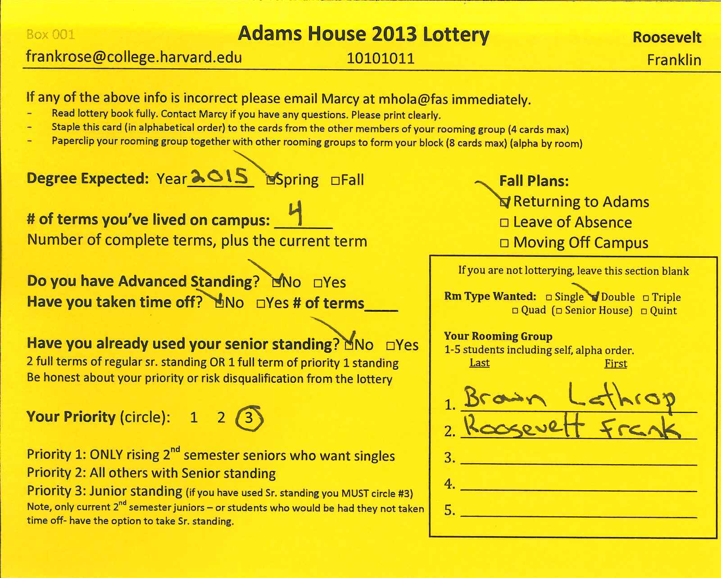
After completing the Housing Questionnaire (HQ), eligible participants will receive a yellow Lottery Card in their mailboxes. If you do not receive one after completing the HQ and distribution is announced, contact Marcy. Students away for the current semester should assign a proxy in the house to handle their lottery participation by contacting Marcy.

To enter the lottery, you must complete both the HQ and turn in your yellow lottery. The information you provide in the questionnaire is used in the event that you become a Free Agent or that an empty space becomes available in your suite. If you know you will not be living in the house next year, please fill out and return a yellow card anyway and simply leave the RG section blank.
When you have decided on the size and composition of your RG, assemble all of the yellow cards for the whole group as follows:
- Arrange all of the cards in your RG in alphabetical order by last name and staple them together in the upper left hand corner.
- If you decide to form a block, securely paper clip together the sets of yellow cards for each RG in the block.
- All yellow cards must be turned in to the House Administrator, Marcy Holabaugh, C-17 by the deadline on page 1. Groups that turn in their cards after the deadline will pick at the end of Night III.

VI. The Lottery Process
All Lottery sessions will take place in the Adams Dining Hall and begin promptly (see Section 1). Blocking groups will be sorted alphabetically, and numbers will be drawn. After all blocking groups have their lottery numbers; we will begin calling groups to pick rooms. Each group will have 1 minute to announce their selection. Night I will be Senior House, followed by singles. Those not successful trying for Senior House may go for singles. There is no blocking allowed on Night I. Night II will be Priority 2, Priority 2 Round 2, followed by mixed groups. Night III will complete the process with Priority 3.

VII. After the Lottery
A. Taking a leave of absence/moving off-campus: If you choose a room but then decide to take a leave of absence or move off-campus, you must complete a Housing Cancellation Form. If you do not complete this form before the deadline, you will be billed for room and board and/or late cancellation fees. You must also contact your roommates so they can talk to the House Administrator about the Free Agent that will fill your space.

B. Free Agents (aka “floaters”): If you are a Free Agent, or a member of your RG decides to take time off, you should contact the House Administrator as soon as possible about potential roommates. All available spaces will be filled before the fall term begins. These decisions will be made with as much attention as possible to the desires of everyone involved.

C. Transferring out of Adams House: If you decide after the lottery that you would prefer to transfer out of the house, this may be accomplished over the summer. Application for Round 2 Interhouse Transfers and the deadline are at the Office of Student Life website.

D. Swapping Rooms: If something changes about your rooming situation (e.g. suite-mate going abroad, injury making selected room inaccessible), all housing changes must be made through the House Administrator. You may not trade rooms or roommates, nor may you give your room away. In the unusual event that a change is necessary, all changes will be executed with respect to personal considerations and issues of priority. In the end, the House Administrator has the authority to place students as she sees fit. The lottery is an optional process.

Adams House

Suite Lottery Frequently Asked Questions

- There are only two of us. Can we choose a triple and get a Free Agent?
No. You must choose a room designated as a double.

- Our roommate is taking fall term off. Can we be guaranteed to room together in the spring?
No. If you can find someone you know is taking spring term off, you can enter the lottery with them. When they leave and your roommate returns, you may request that your prodigal roommate join your room. The schmooze is a great way to discover someone who is planning to take spring term off.

- I may be taking fall term off, but I'm not sure yet. Should I enter the lottery?
That is a personal decision, and you should discuss with your RG whether they would mind getting a Free Agent if you decide to leave, or whether it would be better if you entered the lottery as a Free Agent (or as a single). If you do decide to take a leave of absence, remember to cancel your room contract before the deadline. Note that the contract you signed is valid until you either cancel it or graduate, so be sure to cancel it by the deadline to avoid fees.

- Is it possible to change my rooming configuration when my group's lottery number is called? Example: You go into the lottery as a quad, and when your number is up there are no good quads but some good doubles. Can you pick two doubles?
No. If you want to choose rooms in a different configuration than you entered the lottery, you'll need to PASS when your number comes up, and then regroup for the following session. There are two good reasons for this:
    - If you're in a double and there are 15 other doubles entering the lottery, you should be able to come to the lottery with 16 possible rooms knowing you'll get one of them. Allowing other groups to regroup ahead of you would throw your rooming situation into uncertainty.
    - It's important to work out the best rooming configuration for you in the days and weeks before the lottery; the minute you'll have to choose a room is not a good time to make a snap decision to break up your group.
After the initial list of RG sizes is posted, you will have ONE chance to regroup before your lottery session. This way, if it looks like quads (for example) are extremely popular this year, you can consider changing your configuration in advance.

- Do all of the RGs in a block have to pass if one RG wants to pass?
Nope! One (or two) RGs in a block can pass and the other one (or two) can still choose a room. The groups that pass still have to wait for the end of the night to regroup.

- What happens if we have two groups of the same size in a block, and only one room we want? How do we decide which one has to pass? Rock, paper, scissors in the dining hall?
Please don't! The best way is to decide (or flip a coin) ahead of time which group will get preference.

- We are a group (mostly) of Seniors, but one of our roommates used Senior standing last year (or, is a rising Junior). We really want to live together, and we want Senior housing. Can we enter the Senior Lottery?
No. You will have to enter the lottery as a mixed Junior/Senior group.

- I have advanced standing (or took time off) and decided to take my senior standing to go into the mixed junior-senior lottery, but the senior groups took all the good rooms in the first lottery session. Can I regroup and switch back to Junior Standing (Priority 3)?
No. Once you've gone into the lottery with Senior Standing, you're stuck with it. We don't usually recommend using up your senior standing to enter the mixed junior-senior lottery, as it means you'll never get the chance at true senior housing.

- Can we form a co-ed RG?
Absolutely!

- If my roommate enters the lottery then decides to take fall term off, will I be able to keep the whole room to myself?
No. Vacancies are filled by Free Agents from the sophomore, junior, and senior classes according to info given on the housing questionnaire.

- We're a 5-person rooming group of three seniors and two juniors. If there are no quints left when we pick, in the mixed round will the juniors be able to pick a double?
No. the seniors will be able to pick a triple, but the juniors will have to wait and enter the lottery in Session III.

- If I go through the lottery as a senior, then decide to take time off after the lottery, do I sacrifice my senior standing?
Not in most cases. The main exception is if you lottery with juniors and your senior standing allows them to lottery in session II instead of session III.

- We have a friend who was assigned to Adams but took a year off after freshman year. Now I'm a rising junior but my friend is technically a rising sophomore. Can we still enter the junior lottery?
Yes! Since you both entered Harvard in the same class, you can lottery together this year.
- What happens the year after that? Can we lottery as seniors?
You bet! Since you both entered Harvard in the same class, you can lottery together this year, too.
- What about the year after that? I'll be long gone, but what will happen to my erstwhile roommate? Will s/he now have to take sophomore standing, yet one more insult to add to the hurt and abandonment?
It’s not that bad! I was just getting to that. Your roommate can only take senior standing once, but since junior standing doesn't have quite the same cachet, your roommate will have junior standing for his/her last year, and will be able to enter the junior lottery.
- So then, hey, if I'm a rising sophomore who HASN'T taken time off, but am advanced standing, can I take junior standing now?
Nice try, Mr. Smarty-Pants Advanced Standing. You'll be housed with all the other rising sophomores.
- But what happens if I'm a rising junior or senior who really wants to room with a rising sophomore who HASN'T taken time off, such as Mr. Smarty-Pants Advanced Standing, above? Can I still enter the lottery?
If you are a rising junior, you can float and then you and your potential roommate can contact the House Administrator with preferences among the rooms that are left. Although you will probably be housed over the summer with the rest of the Free Agents and sophomores, you will get housing preference over all of the sophomore-only groups. Same if you are a rising senior and really want to live with a rising sophomore.

- I'm a junior Free Agent, do I even need to show up at the lottery at all?
Nope! Unless, of course, you just want to sit back and watch the spectacle.

- Hey House Administrator, when does storage start and how does it work?
Any questions about storage should be addressed to the Building Manager, Jorge Teixeira.

- This document is peppered with warnings and stern pronouncements, and it all seems very frightening. What can I do to make my lottery experience less stressful?
Do your homework -- visit rooms, ask seniors for opinions, think about who rooms went to in previous lotteries, talk with the House Administrator, and come to the lottery with a list of all the rooms for your group size, in the order you wish to pick them. If you're in a double group, and there are 24 other double groups in the lottery, then if you come with an ordered list of your top 25 available doubles, then all you need to do is tick them off one by one until your lottery number is called. You may also want to decide in advance at what point you would rather pass and regroup later. If you have other considerations (i.e., you want to be close to or far from certain people), then you just need to put together a longer prioritized list.

Glossary
N+1 Suite: has one more room than people. A 3-person suite with three bedrooms and a study is N+1.
N Suite: has the same number of rooms and people. A 2-person suite with one bedroom and a study is N.
N+P Suite: has a partition (usually in the study) creating an additional private space. Best to visit the suite. If you find a partition is a suite that is not listed as N+P, it has been built in violation of house policy and will likely be removed before you move in.
Walk through: a suite where you must walk through a bedroom to access the bathroom or another bedroom. This designation is based on the geography of the suite, and does not consider the number of people living in the suite and if it is likely someone might be sleeping in the study.

-End-

